**TF3, C4, W1**

Quiz

**Question 1** **- checkbox, shuffle, partial credit**

In Neural Style Transfer when initializing the *generated image* from the *content image,* which of the following is true? Check all that apply.

*A: Initially the *content loss* will be equal or close to zero because both the *content image* and *generated* image are the same image.

Feedback: Correct!

*B: Your goal for the *generated image* is to increase the *content loss* and decrease the *style loss*, while keeping the overall *accumulated loss* low.

Feedback: Correct! Since the *generated image* is initialized from the *content image*, you want it to inherit attributes from the *style image* (reduce *style loss*), but also not lose all of its attributes inherited from the *content image* (increase *content loss*).

C: Initially the *style loss* will be equal or close to zero because both, the *content* and *generated*, images are the same.

Feedback: Incorrect! *Style loss* will be high as there is no similarity between the *generated image* and the *style image*.

D: Your goal for the *generated image* is to increase the *style loss* and decrease the *content loss* while keeping the overall *accumulated loss* low.

Feedback: Incorrect! Increasing the *style loss* means don’t inherit anything from the *style image* into the *generated image*, which is not what your target is. You want to *impose* the *style* on the *content image*.

**Question 2** **- multiple choice, shuffle**

What does tf.keras.applications.vgg19.preprocess_input do?

*A: The function centers the distribution of pixel values of an image around zero.

Feedback: Correct! This is called standardization.

B: The function sets the pixel values of an image between 0 and 1.

Feedback: Incorrect! This is called normalizing an image, and *preprocess_input* does not perform normalization.

**Question 3** **- multiple choice, shuffle**

From which part of a CNN architecture can you extract the “content” of an image?

A: The initial layers of the architecture.

Feedback: Incorrect! If you recall the lecture we used only the deeper layer of the CNN for computing *content loss* because that layer holds the information of the *content* of an image.

*B: From the deeper layers of the architecture.

Feedback: Correct! If you recall the lecture we used only the deeper layer of the CNN for computing *content loss* because that layer holds the information of the *content* of an image.

**Question 4** **- text match**

Consider the values given in the image below and calculate the *content loss* value.

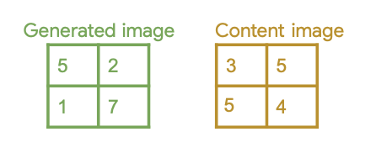

*A: 19

Feedback: Correct!

Default Feedback: Hints: Element-wise subtraction,  
Element-wise square,  
Reduce sum,  
Scale by ½

**Question 5** **- checkbox, shuffle, partial credit**

Fill in the missing code below:

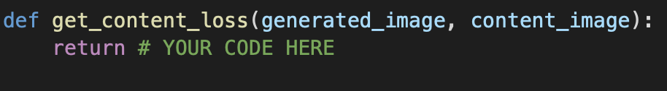

*A: 0.5 * tf.reduce_sum(tf.square(generated_image - content_image))

Feedback: Correct!

B: tf.reduce_sum(tf.square(generated_image - content_image))

Feedback: Incorrect! You are not accounting for the “scaling” of the loss.

*C: 0.5 * tf.reduce_sum(tf.square(content_image - generated_image))

Feedback: Correct! Even though the original formula is *generated_image - content_image*, since you are *squaring* the difference it doesn’t matter what you subtract out of what.

D: tf.reduce_sum(tf.square(content_image - generated_image))

Feedback: Incorrect! You are not accounting for the “scaling” of the loss.

**Question 6** **- text match**

Consider the following code snippet. How will you include *Total Loss Variation* in it? Use TensorFlow as *tf.*

(Answer in the format, **x + y(z)**, considering python’s spacing convention)

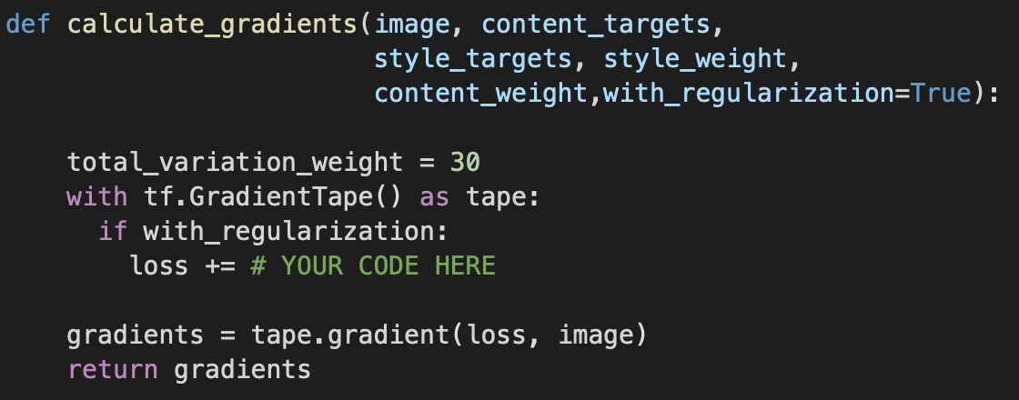

*A: total_variation_weight * tf.image.total_variation(image)

Feedback: Correct!

B: total_variation_weight + tf.image.total_variation(image)

Feedback: Incorrect! You have to multiply, not add.

Default Feedback: (1) Check your spellings.  
(2) Are you considering the weights to update the loss?  
(3) For more help refer back to the lecture *Total Loss Variation*